Day 4 – Solution Validation & Product Strategy
Project
ProcurAgent – AI-Powered Automotive Procurement & Supplier Risk Management System
Day 4 Summary
Day 4 focused on validating the proposed solution, understanding the current and future workflow, defining the technology stack, and understanding the high-level architecture of the system.
Concepts Learned
1. Solution Validation
Checking whether the proposed solution actually addresses the identified business problem and user needs.
2. Product Strategy
The overall plan for how a product will solve a problem, deliver value to users, and decide what should be built and prioritized.
3. AS-IS Process
The current way a business process works before introducing the proposed solution.
4. TO-BE Process
The desired future process after the proposed solution is implemented.
5. Technology Stack
The collection of technologies used to develop and operate a software system.
ProcurAgent Stack:
- Frontend: React + Vite
- Backend: FastAPI
- AI Orchestration: SNS Agent Workbench
- ML / Intelligence: Python
- Database: PostgreSQL
6. System Architecture
The overall structure of a software system, showing its major components and how they communicate.
ProcurAgent flow:
User → React/Vite → FastAPI → SNS Agent Workbench → Python ML/Intelligence → PostgreSQL
7. HLD
HLD (High-Level Design) is a broad technical design that describes the major components, services, data flow, and interactions of a system.
8. Component
A major building block of a software system that performs a specific responsibility.
Example: Frontend, Backend/API, Agent Orchestration, ML/Intelligence, Database.
9. Component Diagram
A diagram that represents the major software components and the relationships or dependencies between them.
10. Architecture Pattern
A commonly used approach for organizing the structure of a software system.
Examples include:
- Layered Architecture
- Microservices Architecture
- Event-Driven Architecture
11. API
API (Application Programming Interface) is a mechanism that allows different software components or systems to communicate and exchange data.
12. Data Flow
The movement of data between different components or stages of a system.
Example:
Supplier Data → API → Agent → ML Analysis → Risk Result → Dashboard
13. Integration
Connecting different software systems or components so that they can exchange information and work together.
14. Dashboard
A visual interface that presents important information, KPIs, alerts, and insights in one place.
15. KPI
KPI (Key Performance Indicator) is a measurable value used to evaluate business or system performance.
Examples:
- Supplier On-Time Delivery %
- Risk Detection Accuracy
- Procurement Decision Time
- Inventory Coverage
16. Data Interpretation
Understanding and drawing meaningful conclusions from tables, charts, graphs, and numerical data.
17. Lead Time
The time between initiating a process and receiving the expected result.
Procurement example:
PO Placed → Component Received
18. Stock Availability
The amount of required material that is currently available for use.
19. Inventory Turnover
A measure of how frequently inventory is used or sold and replaced during a given period.
20. Average
A measure calculated by adding all values and dividing the total by the number of values.
21. Ratio
A comparison between two quantities.
22. Proportion
A relationship where two ratios are equal.

Diagram / Picture Space
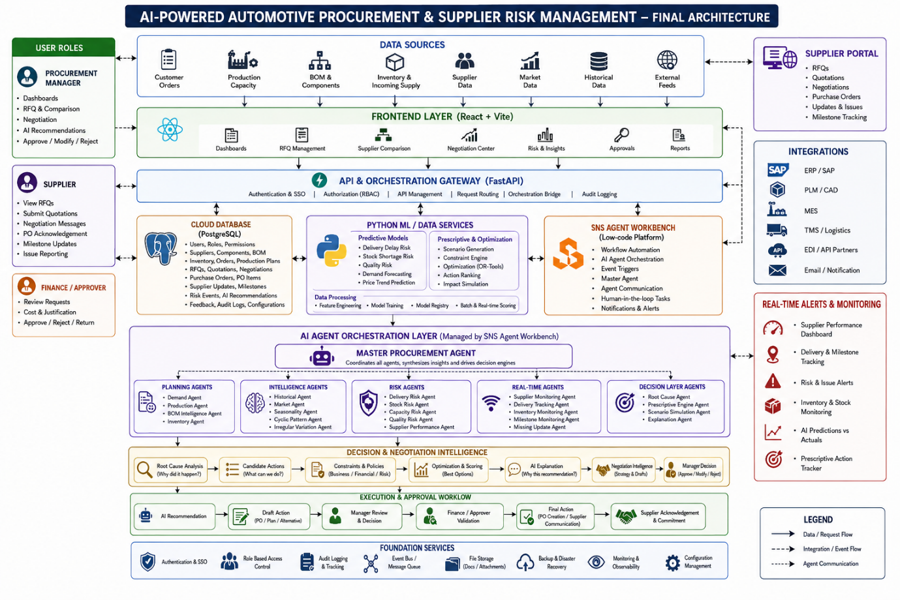

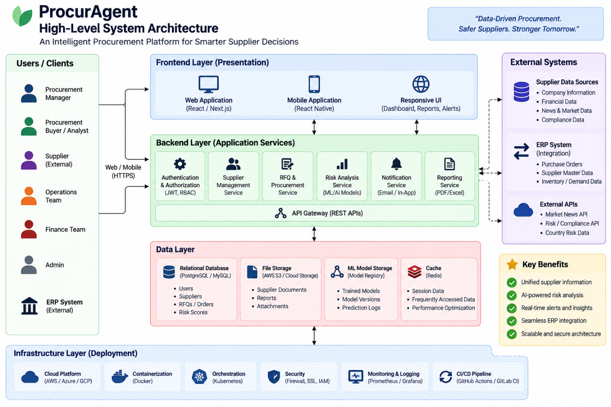
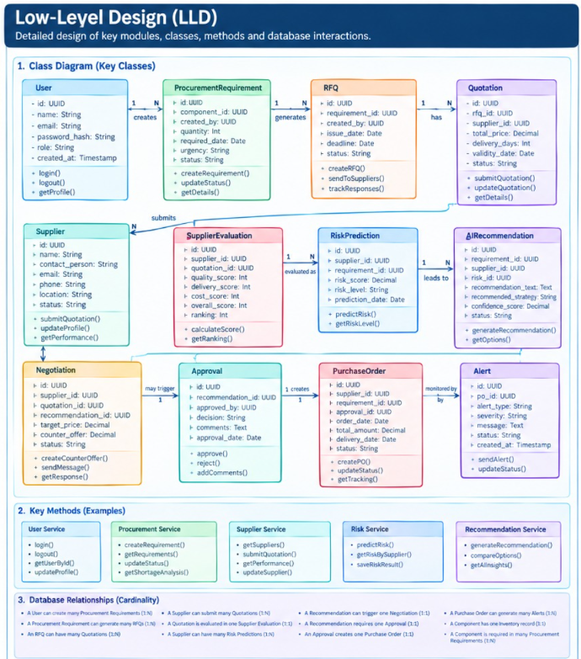

Day 4 Learning Outcome
By the end of Day 4, the concepts of solution validation, product strategy, AS-IS and TO-BE processes, technology stack, system architecture, HLD, components, component diagrams, architecture patterns, APIs, data flow, integration, dashboards, KPIs, and supply-chain data interpretation were understood.
Key Takeaway
Validate Solution → AS-IS → TO-BE → Product Strategy → Tech Stack → HLD → Components → API → Data Flow → Integration → Dashboard → KPI

